2024 UNITED WAY CAMPAIGN
REMINDER EMAIL 5

SUBJECT LINE: Reminder: Pledge Today During the United Way Campaign
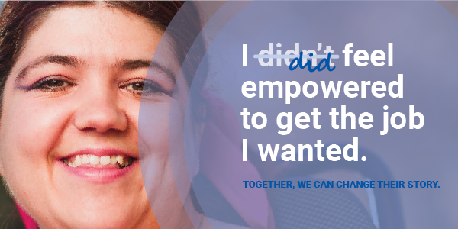

Together, we have the power to change the narrative, turning hardship into hope.

Amanda wanted independence but didn’t know how to secure the job she wanted. With the help learning how to interview, build a resume and how to navigate the workplace, she applied for her first job and has found a sense of belonging and self-sufficiency.

You have the opportunity to truly make a difference for individuals like Amanda, celebrating success in the way their story may change. By investing in United Way, you’re offering a hand-up at times when it’s needed most.

Your commitment ensures help is available for individuals like Amanda and others struggling to afford high-quality childcare, access healthy food, find safe and stable housing and gain confidence and reading skills.

Whose story will you change?

PLEDGE TODAY

If you run a paper campaign, please remove “pledge today” button and insert instructions on how to pledge.
If you or someone you know is struggling, please call 2-1-1 or visit their website.

MEET AMANDA
Amanda struggled with confidence and shyness. She wanted to support herself and gain independence but wasn’t sure where to start.
After connecting with Disability Network, she learned interviewing skills, built a resume, shopped for workplace appropriate clothes and found the courage to apply for her first job! Now she’s equipped with the skills needed to earn an income and become more self-sufficient.

48%
of all people with a disability in Michigan live in a household with an income below the ALICE threshold.

READ HER STORY

Questions? Contact the United Way Helpdesk.

