2024 UNITED WAY CAMPAIGN
REMINDER EMAIL 4

SUBJECT LINE: Pledge Today during the United Way Campaign
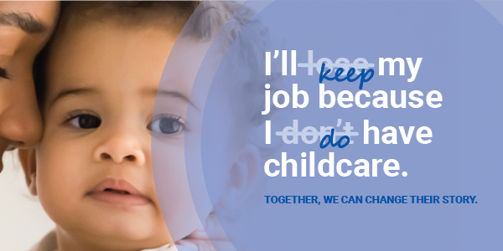

Everyone has a story to share.

For many working parents, affording high-quality childcare to remain employed and have a safe place for their kids to go is a daily challenge. With the support of caring childcare providers and scholarships, families maintain financial stability, kids make new friends and are equipped with social-emotional skills, allowing parents have peace mind that their kids are in good care while they are at work.

This story is far too common, but together we have the power to change it.

You play an integral role in creating a healthy community where everyone has the opportunity to thrive. Your engagement with Untied Way is a catalyst for positive change for our community today and for generations to come.

Your commitment ensures help is available for families like Avery’s and others struggling to build vital job skills, find safe and stable housing, access healthy food and gain confidence and reading skills.

Whose story will you change?

PLEDGE TODAY

If you run a paper campaign, please remove “pledge today” button and insert instructions on how to pledge.

If you or someone you know is struggling, please call 2-1-1 or visit their website.

MEET AVERY
Avery’s family was connected with a local family center, they received the care and understanding they deserved. To support their household, bother parents needed to work which made having reliable childcare critical. The center provided more than just a place for their kids to go, they understood their challenges and worked with them to ensure their children has the best care possible.

33%
of Midland County families spend nearly 30% of their household income on childcare.

READ HER STORY

Questions? Contact the United Way Helpdesk.

