2024 UNITED WAY CAMPAIGN
REMINDER EMAIL 2

SUBJECT LINE: Help Ensure Kids have the Confidence and Skills to Reach their Full Potential
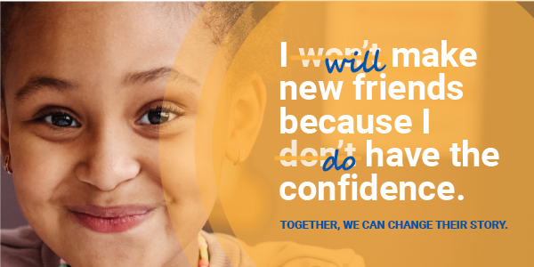

We all have a story to share.

Emma was a shy 2nd grade student who needed extra help learning and building social-emotional skills. After she was paired with a positive adult mentor, her confidence grew, and she caught up with her classmates. Now, she has a newfound love of reading and has set herself a goal to make new friends at school next year.

This story is far too common, but together we have the power to change it.

Your gift to United Way changes the stories of our neighbors. The dollars raised go directly into our community, ensuring our friends, families, coworkers and neighbors are supported during a time in their life they need it most.
Your commitment ensures help is available for neighbors like Emma and others struggling to afford high-quality childcare, build vital job skills, find safe and stable housing and access healthy food.

Whose story will you change?

PLEDGE TODAY

If you run a paper campaign, please remove “pledge today” button and insert instructions on how to pledge.
If you or someone you know is struggling, please call 2-1-1 or visit their website.

MEET EMMA
Emma was a shy elementary student and had been through so much at a young age. After losing her mom, her and her siblings moved in with their grandma.
Recognizing that Emma needed a little more support, her teacher recommended she join LunchBox Learners. After being paired with Lynn, Emma found her voice and blossomed. She’s now confident, caught up to 4th grade reading level and has set a goal to make new friends at school next year!

52%
of third-grade students are not reading at
grade level.

READ HER STORY

Questions? Contact the United Way Helpdesk.

