2024 UNITED WAY CAMPAIGN
REMINDER EMAIL 1

SUBJECT LINE: Pledge Today to Help Ensure Families have Access to Health Food
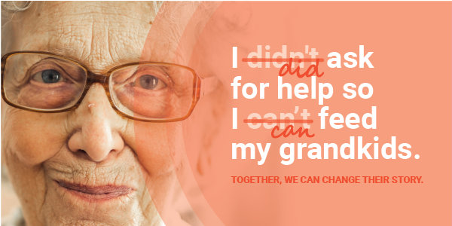

Our neighbors have many different stories.

After the loss of her daughter and husband, Joan struggled to provide healthy, nutritious food for her and her grandkids. After connecting with community food resources, they no longer had to worry about where their next meal would come from.

This story is far too common, but together we have the power to change it.
You have the opportunity to truly make a difference for families in our community, celebrating success in the way their stories are changed. By investing in United Way, you’re offering a hand-up at times in people’s lives when they need it most.

Your commitment ensures help is available for families like Joan’s and others struggling to afford high-quality childcare, build vital job skills, find safe and stable housing and gain confidence and reading skills.

Whose story will you change?

PLEDGE TODAY

If you run a paper campaign, please remove “pledge today” button and insert instructions on how to pledge.
If you or someone you know is struggling, please call 2-1-1 or visit their website.

MEET JOAN
Joan never imagined she would be raising her three grandchildren alone. The sudden loss of her daughter was devastating and just when she thought things couldn’t get worse, her husband passed away too. Without enough to make ends meet, Joan found herself struggling to afford groceries to feed her family.
With the help of West Midland Family Center, they now receive fresh produce to nourish their bodies and minds. WMFC has become like family to them, surrounding them with love, care and nourishment.

11.4%
of Midland County residents
are food insecure.

READ HER STORY

Questions? Contact the United Way Helpdesk.

