2024 UNITED WAY CAMPAIGN
REMINDER EMAIL 3

SUBJECT LINE: Reminder: Pledge Today to Ensure Neighbors have Safe and Stable Housing
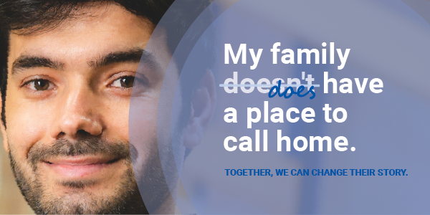

Our neighbors have many different stories.
After Trevor and his girlfriend faced unexpected surgery and job loss, they struggled to afford the basics and fell behind on rent. With support from their landlord, they were connected with 2-1-1 and provided the assistance they needed to stay in their home and get back on their feet.
This story is far too common, but together we have the power to change it.

Your investment in United Way creates a visible and measurable impact. The dollars we raise together go directly into local community programs to ensure all people can thrive.

Your commitment ensures help is available for families like Trevor’s and others struggling to afford high-quality childcare, build vital job skills, access healthy food and gain confidence and reading skills.

Whose story will you change?

PLEDGE TODAY

If you run a paper campaign, please remove “pledge today” button and insert instructions on how to pledge.

If you or someone you know is struggling, please call 2-1-1 or visit their website.

MEET TIM
When Tim’s girlfriend had unexpected surgery, the stress of managing their financial stability began to weigh on them. Then, Tim lost his job. The bills began to pile up, leaving Tim with increasing anxiety and depression.
After connecting with 211, they received the help they needed to stay safely homed while getting back on their feet.

30%
of local families are spending more than
30% of their income on housing, making
them housing cost-burdened.

READ HIS STORY

Questions? Contact the United Way Helpdesk.

