2024 UNITED WAY CAMPAIGN
CAMPAIGN KICK-OFF EMAIL

SUBJECT LINE: Whose story will you change?
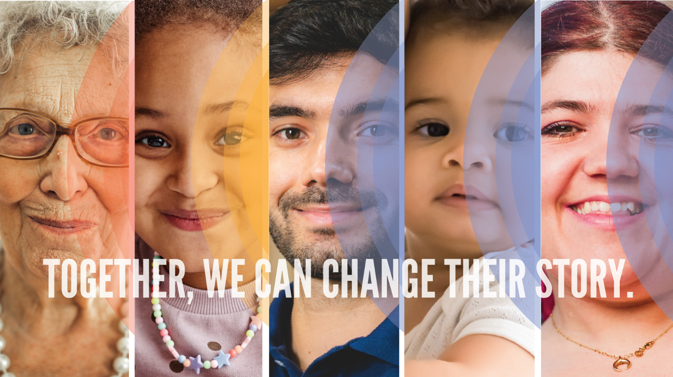

Every day, our neighbors face a multitude of challenges. Families struggle to put food on the table, kids fall behind on reading skills and lack confidence, adults aren’t equipped with the skills to find employment, parents can’t afford high-quality childcare and many of our neighbors don’t have a safe place to call home.
These stories are all too common, but together, we have the power to change them.
Today marks the start of [Company Name] United Way Campaign. We've set a goal to raise [Goal] for our community. But this campaign is not just about reaching a goal. It's about changing the lives of those who need our support.
Each of us plays an integral role in creating a healthy, thriving community. Your engagement with United Way is a catalyst for positive change, helping to strengthen the fabric of our community for today and generations to come.
United Way addresses the most pressing health and human service needs in the areas of Youth Success, Health and Household Stability. Your commitment to investing in United Way ensures there are vital community programs available for our family, friends, coworkers and neighbors.
Together, we can transform hardship into hope and rewrite the narrative for our those who need our support.
Although we may never meet all the people whose lives have been changed, they will forever be grateful that help was available when they needed it most.
Whose story will you change?
PLEDGE TODAY

If you run a paper campaign, please remove “pledge today” button and insert instructions on how to pledge.

If you or someone you know is struggling, please
call 2-1-1 or visit their website.

Questions? Contact the United Way Helpdesk.

